Lab: File Path Traversal
🧪 Lab Overview
This lab demonstrates a File Path Traversal vulnerability in the functionality used to display product images.
The objective of the lab was to retrieve the contents of the /etc/passwd file from the server.
Lab Details:
Lab Name: File path traversal, simple case
Level: Apprentice
Vulnerability Type: File Path Traversal
Target File: /etc/passwd
Status: Solved

🧠 How I Approached the Problem
My approach was to first understand how the application loaded product images. Since the lab description mentioned that the vulnerability existed in the display of product images, I focused on the requests generated when product images were loaded.
I configured my browser to send traffic through Burp Suite using the FoxyProxy extension. Then, I intercepted the requests and analyzed them to identify parameters related to file paths or filenames.
During the analysis, I found a request containing the parameter:
filename=30.jpg
This parameter indicated that the application was accepting a filename through the request. I then moved the request to Burp Suite Repeater and tested whether the filename could be manipulated to access files outside the intended directory.
Finally, I replaced the original filename with a path traversal payload:
../../../etc/passwd
The server returned the contents of the /etc/passwd file, confirming the vulnerability.

📸 Screenshot-by-Screenshot Explanation
Screenshot 1 – Lab Introduction
The first screenshot shows the introduction to the lab.
The lab is titled:
File path traversal, simple case
The description explains that the application contains a path traversal vulnerability in the display of product images.
The objective of the lab is to retrieve the contents of:
/etc/passwd
The lab is categorized as an Apprentice-level lab.
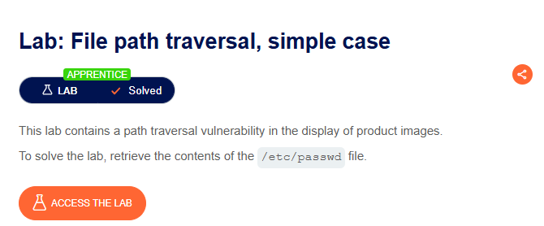
Screenshot 2 – Accessing the Lab
In this step, I clicked the Access the Lab button.
The application opened the lab environment and redirected me to the homepage.
The homepage displayed multiple products, each containing an image and a View details option.
Since the vulnerability was mentioned in the product image functionality, I focused on analyzing how these images were being loaded.

Screenshot 3 – Configuring FoxyProxy
Before intercepting the application's requests, I enabled the FoxyProxy browser extension.
FoxyProxy was configured to route the browser traffic through Burp Suite.
This allowed me to capture and analyze the HTTP requests sent between the browser and the web application.
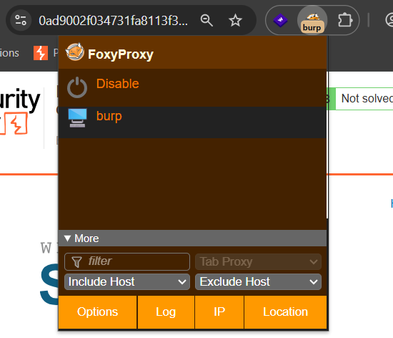
Screenshot 4 – Enabling Burp Suite Intercept
Next, I opened Burp Suite and navigated to:
Proxy → Intercept
I enabled the Intercept option.
This allowed Burp Suite to stop incoming HTTP requests so that I could inspect them before they were sent to the server.
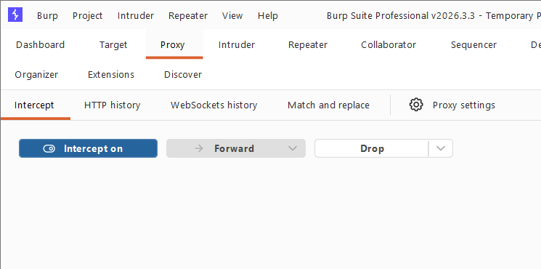
Screenshot 5 – Refreshing the Homepage
After enabling interception, I returned to the lab homepage and refreshed the page.
Refreshing the page generated multiple HTTP requests, including requests related to the webpage resources and product images.
Burp Suite captured these requests for analysis.
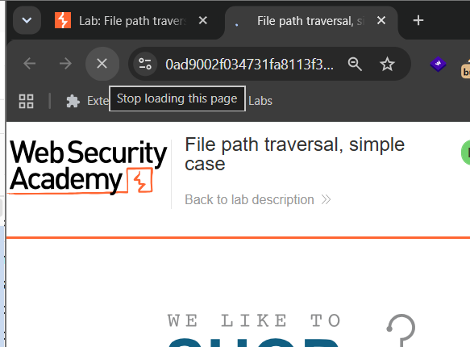
Screenshot 6 – Analyzing the Captured Requests
I started examining the requests captured by Burp Suite.
Initially, the requests I captured did not contain an obvious path or filename parameter related to the vulnerability.
Therefore, I continued forwarding the requests and checking the next captured requests.
My goal was to identify a request that was responsible for loading a product image.
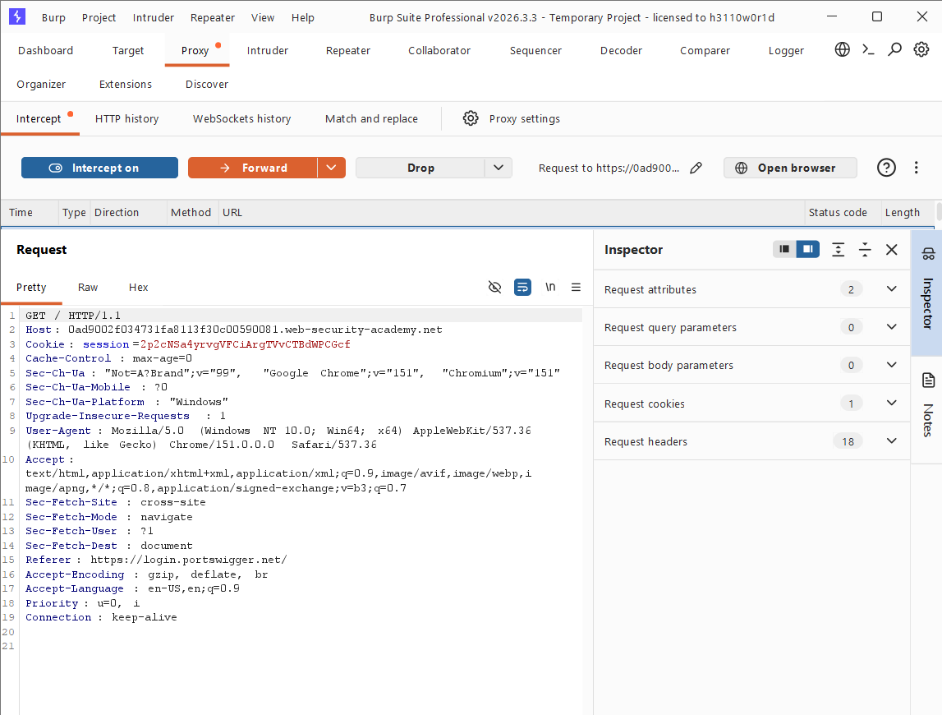
Screenshot 7 – Identifying the Filename Parameter
While analyzing the intercepted requests, I found the following request:
GET /image?filename=30.jpg
The important part of the request was:
filename=30.jpg
This indicated that the application was receiving the image filename directly through a request parameter.
This became the main parameter for testing the File Path Traversal vulnerability.
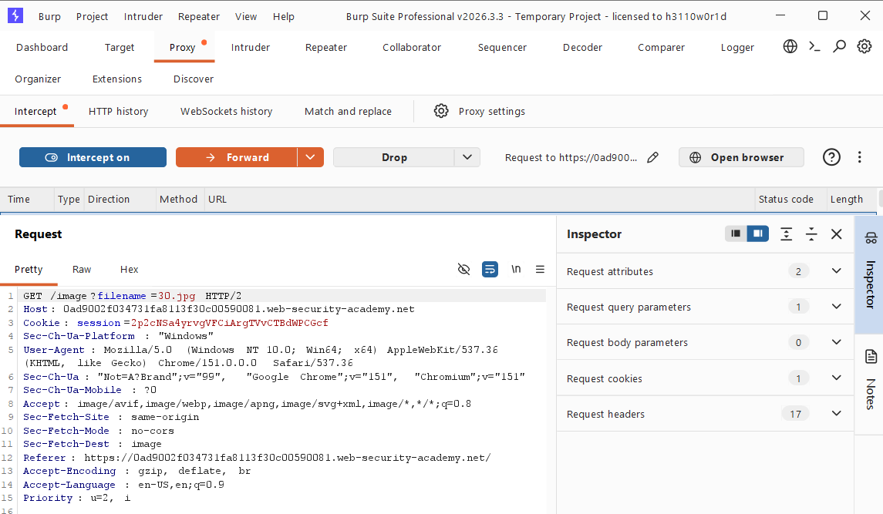
Screenshot 8 – Sending the Request to Repeater
To test the request safely and repeatedly, I right-clicked the captured request.
Then, I selected:
Send to Repeater
Burp Suite Repeater allowed me to modify the request manually and observe the server's response.
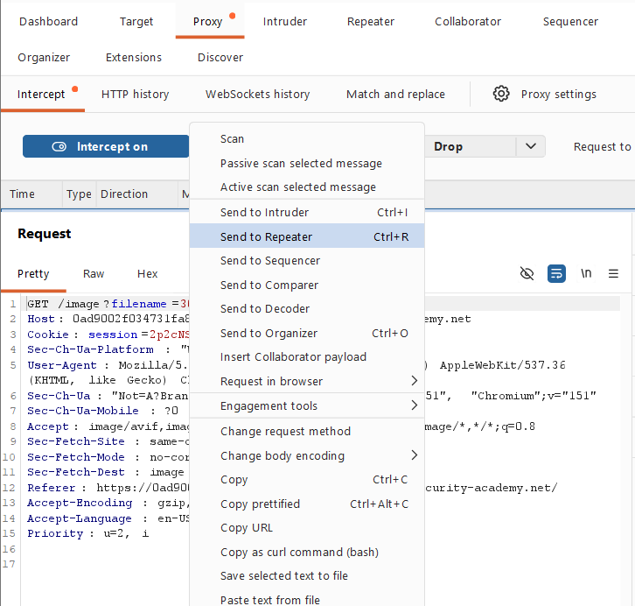
Screenshot 9 – Opening the Request in Repeater
The request was successfully opened in the Repeater tab.
The request contained the following path:
/image?filename=30.jpg
At this stage, I was ready to test whether modifying the filename parameter would allow access to files outside the intended image directory.s

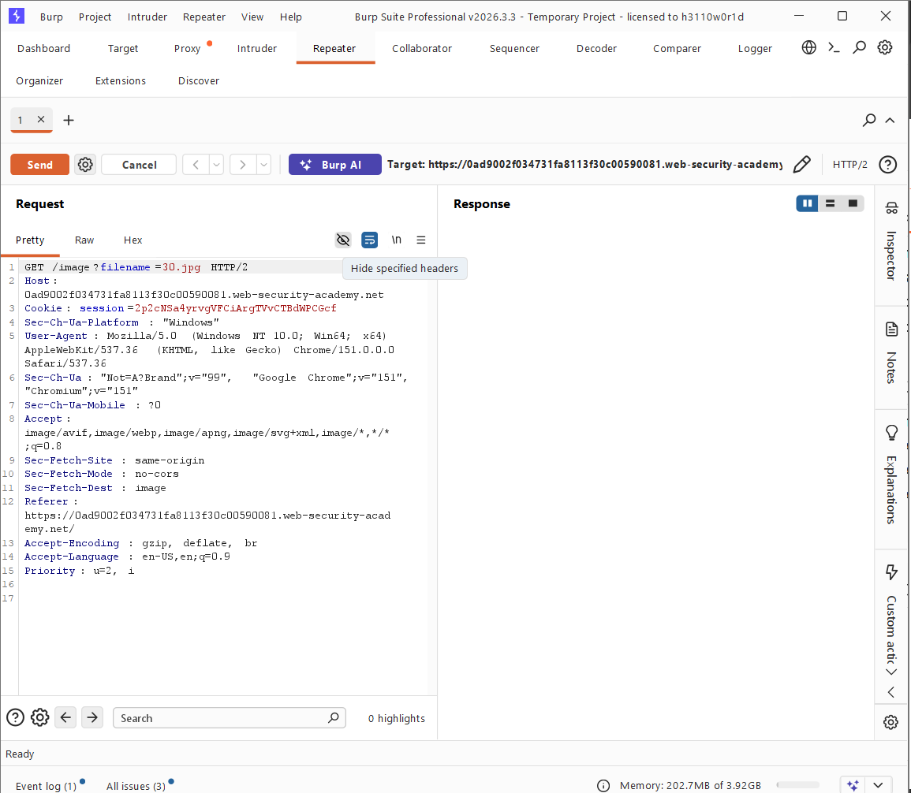
Screenshot 10 – Testing the Original Request
Before modifying the request, I clicked the Send button to observe the normal server response.
The server returned:
HTTP/2 200 OK
This confirmed that the request was valid and that the application successfully returned the requested image.
Testing the original request first helped confirm that the filename parameter was functioning as expected.
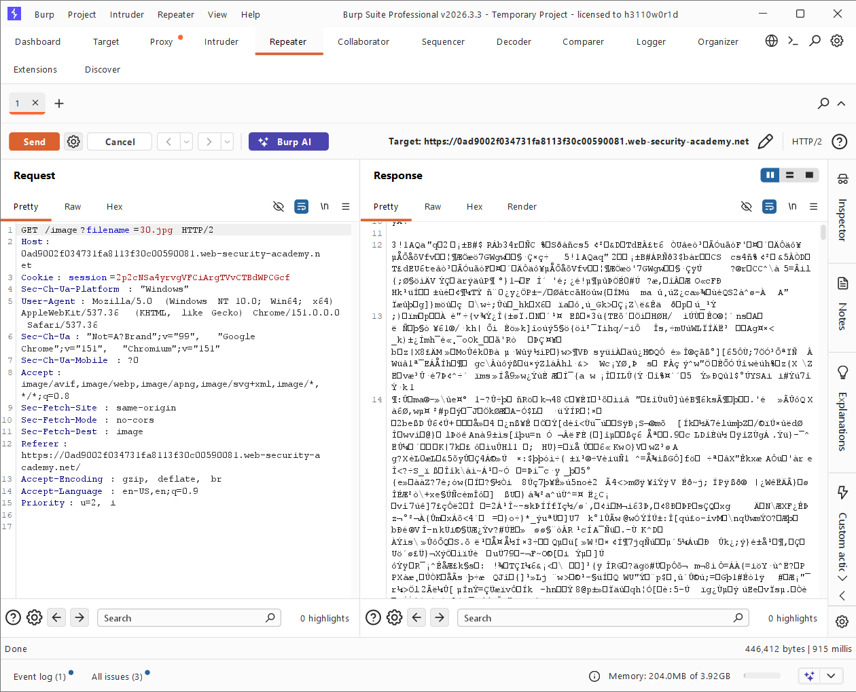
Screenshot 11 – Testing for File Path Traversal
Next, I replaced the original filename:
30.jpg
with the following payload:
../../../etc/passwd
The modified request became:
GET /image?filename=../../../etc/passwd
I then clicked the Send button.
The server returned the contents of the /etc/passwd file.
The response contained entries similar to:
root:x:0:0:root:/root:/bin/bash
daemon:x:1:1:daemon:/usr/sbin:/usr/sbin/nologin
bin:x:2:2:bin:/usr/sbin:/usr/sbin/nologin
This confirmed that the application was vulnerable to File Path Traversal.
Note: /etc/passwd typically contains user and account information. It does not normally contain users' actual passwords on modern Linux systems.

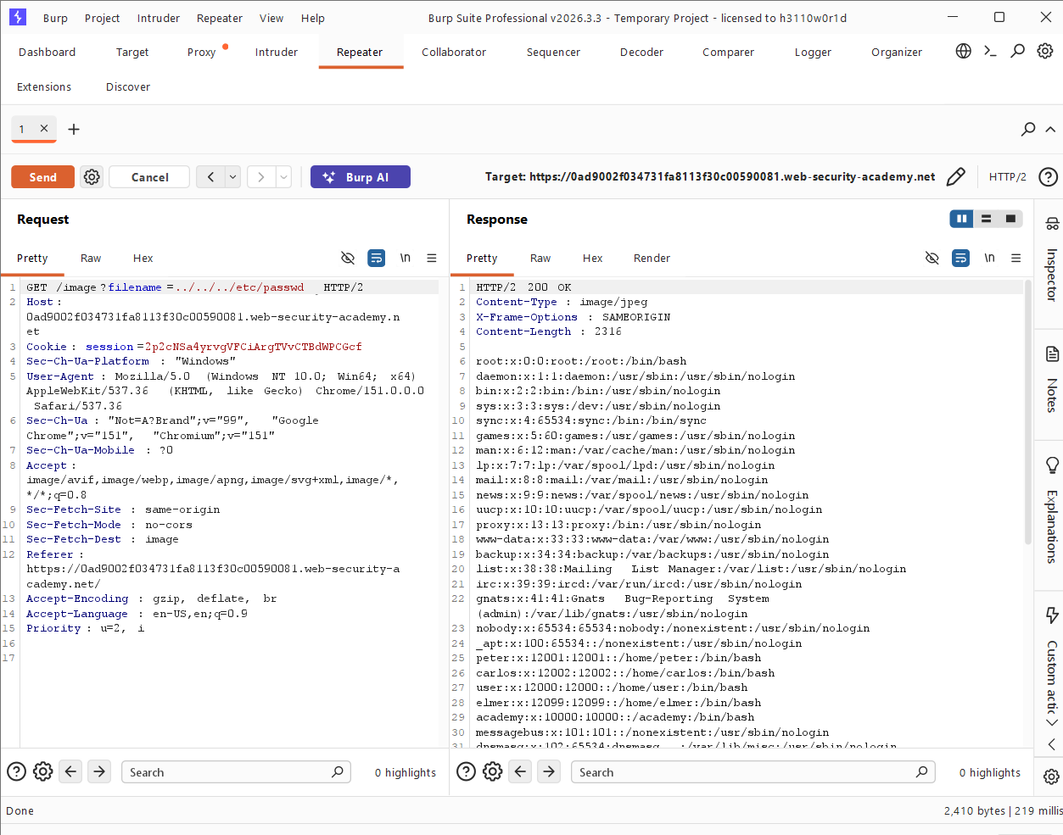
Screenshot 12 – Lab Successfully Solved
The final screenshot confirms that the payload successfully exploited the vulnerability.
The lab displayed:
Solved
This confirmed that the objective of retrieving the /etc/passwd file had been successfully completed.
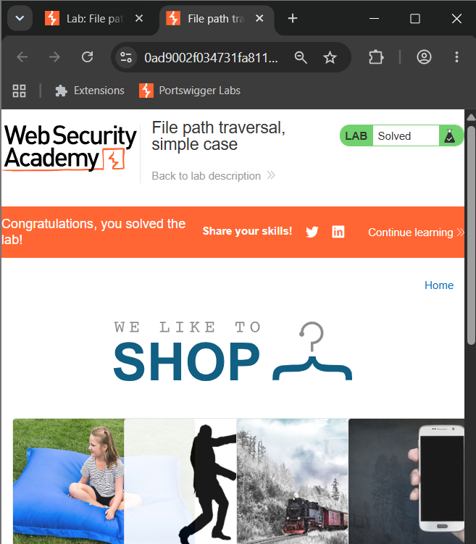
🔍 Different Possibilities I Considered
While analyzing the application, I considered the following possibilities:
1. Direct File Name Manipulation
The application used a parameter like:
filename=30.jpg
I checked whether the filename value could be modified.
2. Directory Traversal
I tested whether directory traversal sequences could allow movement outside the intended image directory.
Example:
../../../etc/passwd
3. Server Response Analysis
I used Burp Suite Repeater to compare the normal response with the modified response.
The normal request returned an image, while the modified request returned the contents of a system file.
⚡ How the Vulnerability Was Confirmed
The vulnerability was confirmed when the following request was sent:
GET /image?filename=../../../etc/passwd
The application responded with:
HTTP/2 200 OK
The response body contained the contents of:
/etc/passwd
This proved that the application did not properly restrict the file path supplied through the filename parameter.
🎯 Root Cause
The root cause of the vulnerability was improper validation of user-controlled file paths.
The application allowed the filename parameter to influence which file was accessed.
Instead of restricting the application to a specific directory, the application accepted directory traversal sequences such as:
../
This allowed navigation outside the intended directory.
For example:
filename=30.jpg
was changed to:
filename=../../../etc/passwd
As a result, the application accessed a sensitive system file instead of only accessing product images.
🛡️ Remediation
To prevent File Path Traversal vulnerabilities, applications should implement the following security measures:
1. Avoid Using User Input Directly in File Paths
User-controlled input should not be directly used to construct file system paths.
2. Use an Allowlist
Only allow expected filenames or file identifiers.
For example, instead of accepting arbitrary paths, validate that the requested file matches an approved format.
3. Remove Path Traversal Sequences
The application should detect and reject dangerous sequences such as:
../
4. Use Canonical Path Validation
The application should resolve the final file path and verify that it remains inside the intended directory.
For example:
/images/products/
The resolved file path should never be allowed to escape this directory.
5. Apply the Principle of Least Privilege
The web application should run with minimal file system permissions.
Even if a vulnerability exists, restricted permissions can reduce the potential impact.
📚 Key Learning
Through this lab, I learned how File Path Traversal vulnerabilities can occur when an application accepts file-related input without proper validation.
I also learned how to:
- Configure FoxyProxy with Burp Suite.
- Intercept HTTP requests.
- Analyze request parameters.
- Identify a filename parameter.
- Send requests to Burp Suite Repeater.
- Modify request parameters.
- Compare normal and modified server responses.
- Confirm a File Path Traversal vulnerability.
🎓 My Biggest Takeaway
My biggest takeaway from this lab is that user-controlled input should never be trusted without proper validation.
A simple parameter such as:
filename=30.jpg
can become dangerous if an attacker is allowed to modify it to:
../../../etc/passwd
This lab clearly demonstrated how improper input validation and missing access restrictions can allow unauthorized access to files on a server.
🏁 Conclusion
In this lab, I successfully identified and exploited a File Path Traversal vulnerability in the product image functionality.
By intercepting HTTP requests with Burp Suite, I identified the following parameter:
filename=30.jpg
I then sent the request to Burp Suite Repeater and modified the value to:
../../../etc/passwd
The application returned the contents of the /etc/passwd file, confirming that the application was vulnerable to File Path Traversal.
The lab was successfully solved.
🧠 Learning Summary
1. Understand the application functionality.
↓
2. Identify the feature mentioned in the lab description.
↓
3. Configure FoxyProxy with Burp Suite.
↓
4. Enable Proxy Intercept.
↓
5. Refresh the application.
↓
6. Analyze captured HTTP requests.
↓
7. Identify the filename parameter.
↓
8. Send the request to Repeater.
↓
9. Test the normal request.
↓
10. Modify the filename parameter.
↓
11. Use a path traversal payload.
↓
12. Analyze the server response.
↓
13. Confirm the vulnerability.
↓
14. Lab Solved Successfully.
🔐 Vulnerability Type
File Path Traversal
A File Path Traversal vulnerability occurs when an application does not properly validate user-controlled file paths, allowing an attacker to access files or directories outside the intended location.
In this lab, the vulnerable parameter was:
filename
The vulnerable request was tested using:
../../../etc/passwd

